

Project: Campaign Automation

May 2017

Overview

Lifecycle journey

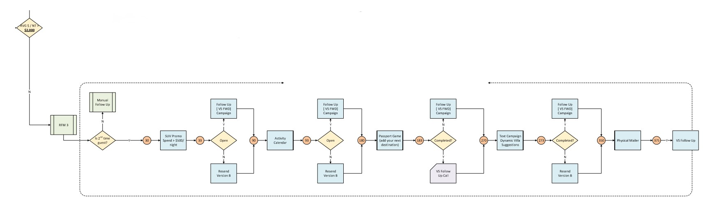

Overall Target

* Repeat guests (bookings > 1)
* AVR Spend x night < $2500

Automation criteria

* Daily to the target audience

Exclusions

* Last Outbound Communication < 21 Days
* Last Inbound Communication < 7 Days

*No communication exclusion on 1st touchpoint

Campaign location

**My Templates > Guests > RFM 2016 > Lifecycle guests 2017**

**My Emails > Guests > RFM 2016 > Lifecycle guests 2017**

Detailed campaigns:

**First batch:**

The repeat series should start after 30 days of a second booking. All other campaign rules will follow in the order below:

|  |  |  |
| --- | --- | --- |
| **Campaign name** | **Automation trigger** | **Send Classification** |
| SUV Promotion - March 2017 - $500 | 2nd guest + 30 days + Spend ≥ $500/ night | 2017_Editor |
| Events - Activity Calendar | 2nd guest + 90 days | 2017_Editor |
| Passport 2017 | 2nd guest + 180 days | 2017_Editor |
| Dynamic Villa Suggestions | 2nd guest + 270 days | VS - Responsive_No header-footer |

Depending on the reaction of the user to the emails above (opened or didn’t open), the second batch options are triggered.

Note: **Dynamic Villa Suggestions** is missing the 3 villa recommendations in the template. To define.

**Second batch:**

This batch should follow the rules below:

|  |  |  |
| --- | --- | --- |
| **Campaign name** | **Automation trigger** | **Send Classification** |
| SUV Promotion - March 2017 - follow up - $500 | SUV Promotion - March 2017 + 3 days after send date + opened | VS - Responsive_No header-footer |
| SUV Promotion - March 2017 - Re-send - $500 | SUV Promotion - March 2017 + 3 days after send date + didn’t open | 2017_Editor |
| Events - Activity Calendar - follow up | Events - Activity Calendar + 3 days after send date + opened | VS - Responsive_No header-footer |
| Events - Activity Calendar - Resend | Events - Activity Calendar + 3 days after send date + didn’t open | 2017_Editor |
| Passport 2017 - follow up | Passport 2017 + 3 days after send date + completed game | VS - Responsive_No header-footer |
| Dynamic Villa Suggestions - follow up | Dynamic villa suggestions + 3 days after send date + opened | VS - Responsive_No header-footer |
| Dynamic Villa Suggestions - Resend | Dynamic villa suggestions + 3 days after send date + didn’t open | 2017_Editor |

In short, “follow up” versions will be sent to people who opened the first email and “Re-sends” will be sent to people who didn’t open the first email.

Note:

1. Passport 2017 campaign will not have a Resend version as the customer will be contacted by phone.
2. Dynamic Villa Suggestions is missing the 3 villa recommendations in all related versions.